P U B L I C C O N S U L T A T I O N

July 2004

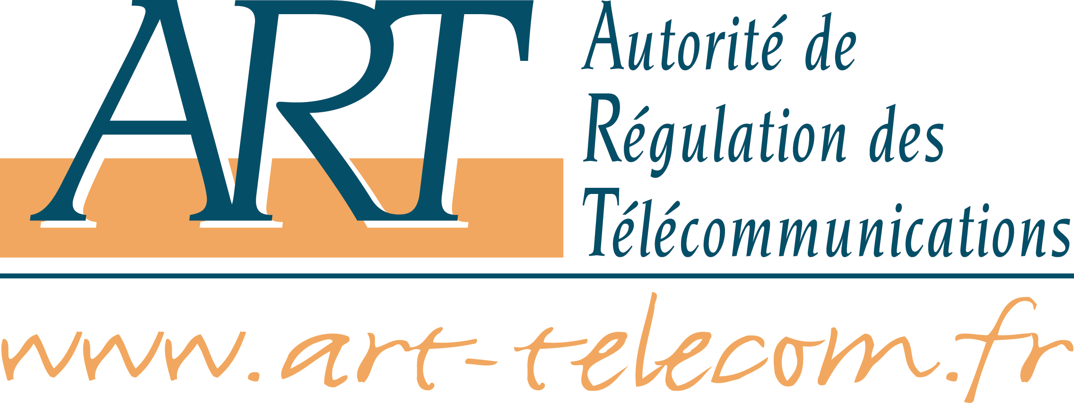

Wireless local loop


Questions of the public consultation
on public wireless local loop networks
3,4 - 3,8 GHz band

(29th of June 2004 – 30th of September 2004)

Content

Information 3
1 – Point to multipoint – Uses – Technologies – Ressources 4
a – Uses 4
b – Point to multipoint technologies 4
c – Bands identifies for point to multipoint uses in public networks 4
2 – 3,4 – 3,8 GHz band 5
a – In "France Métropolitaine" 5
b – In overseas "départements" 5
c – In Mayotte and Saint-Pierre et Miquelon 5
3 – Your projects in the 3,4 – 3,8 GHz band 6
a – General description 6
b – Covering zone 6
4 – Attribution modalities of 3,4 – 3,8 GHz ressources in "France métropolitaine" 7
a – The attribution modalities of type "(1a) larger projects" or "(1b) intermediate projects - BLR1 duplex 7
b – The attribution modalities for type "(2) local projects" 8
c – Technical conditions 8
5 – Attribution modalities of 3,4 – 3,8 GHz band in the overseas "départements" and in Mayotte and Saint-Pierre et Miquelon 9
a – In the overseas "départements" 9
b – In Mayotte and Saint-Pierre et Miquelon 9

Information

The Autorité de régulation des telecommunications (ART) publishes this public consultation about public wireless local loop networks in the 3,4 – 3,8 GHz band. It can be downloaded from ART web site : http://www.art-telecom.fr/eng/corps.htm.

The contributions to this public consultation shall be transmitted to ART before Thursday 30th of September 2004 at noon. These contribution can be send by email : BLR@art-telecom.fr or by postal mail at the following address :

A l'attention de Jérôme Rousseau
Chef du service Opérateurs et Régulation des ressources rares
Autorité de régulation des télécommunications
7, square Max Hymans
75015 Paris
France

Any further information or questions about this document can be asked to the following persons :

Anne Huguet
Head of Operators and Planning Unit
Operators and scarce resources regulation service
email : anne.huguet@art-telecom.fr
+33.1.40.47.70.98

Claire Chamaillard
Operators and Planning Unit
Operators and scarce resources regulation service
email : claire.chamaillard@art-telecom.fr
+33.1.40.47.70.61

1 – Point to multipoint – Uses – Technologies – Ressources

a – Uses

- Do you agree with this distinction?

b – Point to multipoint technologies

- Concerning subscriber connection, do you think that 2,4 GHz RLAN and 3,5 GHz technologies are converging?
- What are the point to multipoint technologies and norms currently available? Are they mature?
- What do the new technologies add up from the existing ones? In the future, what services will they enable? Will these services be comparable to mobile, nomadic services? When will they be available?
- Are 802.16 equipments available? In which band are these equipments developed? For the ones operating in the 3,4 – 3,6 GHz band, what kind of adaptation is required to have them operating in the 3,6 – 3,8 GHz band?
- What are the targeted markets by these new norms and technologies? What is their position on the fixed telecom market? Are they in competition with mobile technologies (eg. UMTS)?
- In the 3,5 GHz and 26 GHz band, the attributed frequencies have been on a FDD basis. Are current and future systems FDD or TDD?

c – Bands identifies for point to multipoint uses in public networks

- What are the technical characteristics of equipments developed in the 5470-5725 MHz band (norms used)?
- Do you think that projects initially thought for the 3,4 – 3,8 GHz band could find their place in the 5470-5725 MHz band if it were to be opened?

- Do you have projects in the 26 GHz band?
- Should other band be looked into for the introduction of point to multipoint systems?

2 – 3,4 – 3,8 GHz band

- Do you believe that this classification reflects the actual projects?

a – In "France Métropolitaine"

- Does the use of 3,6-3,8 GHz resources require an additional development?
- If an additional resource were necessary for type (1) or (2) projects, do you think that the 3,6 – 3,8 GHz frequency band could meet this need?

b – In overseas "départements"

c – In Mayotte and Saint-Pierre et Miquelon

3 – Your projects in the 3,4 – 3,8 GHz band

a – General description

- In which category may you have a project?
(1a) large scale project
(1b) intermediate project
(2) local project
- Could you describe your project (use, target population, service offered, localisation …)?
- What is the topology?
Point to multipoint network
Mesh network
Other : …
- Do you think your project will include a mobility perspective if the technology enables it?

b – Covering zone

- Could you indicate the covering of your wireless project:
National project
One or more regions. Which ones: ……………………
One or more "département". Which ones: ……………………
One or more "communes". Which ones: ……………………
One or more overseas "département". Which ones: ……………………
Mayotte.
Saint-Pierre et Miquelon.
- If appropriate, could you indicate the initial coverage area of your project and the possible extensions?
- If your project is of type (2) local project, what are the sizes of the cities (of the city) included in your project?
- Less than 5 000, 10 000, 15 000, (other) inhabitants "commune"?
- Commune included in a more than 10 000, 15 000, 20 000, (other) inhabitants "unite urbaine"?

- What is the forecast schedule of your project?

4 – Attribution modalities of 3,4 – 3,8 GHz ressources in "France métropolitaine"

- What do you think about such a proposal? Do you think this double attribution modality is suited? What are the risks of a double process of frequency resource attribution?
- Do you think that the local (and quicker) attribution modalities might be used by larger scale project in order not to wait for the selection procedure?
- What should be the articulation between the attribution of 3,4 - 3,8 GHz band and the current and future projects of high speed Internet total covering, some of which are driven by local authorities?

a – The attribution modalities of type "(1a) larger projects" or "(1b) intermediate projects - BLR1 duplex

- What should be the granularity of this resource attribution?
Regional
"Départemental"
Other : ……………..
- What coordination solutions would you recommend at the limits of attribution zones (départements, regions,… limits)?

- In the BLR1 duplex, do you think several operators could share the resource?
- What is the minimal quantity of resource to be attributed to one operator? Does this quantity depend on the attribution scale (départemental, regional, national)?

- If selection procedure is preferred, which of these two options should be chosen: Auction or beauty contest? As for beauty contest, on which criteria should the candidates be evaluated?
- Should there be minimal deployment obligations? Minimal service obligation? Obligation to open the network to other actors?
- If the auction is preferred, should the wireless local loop frequencies, partially or totally, be submitted to spectrum trading?
- What should be the commitments of the operators as far as their authorization to use frequencies is concerned?
- If other resources in the 3,4 – 3,8 GHz band could be made available, do you think ART should wait for these other frequencies to be free before attributing all resources at the same time (possibly on a first come, first served basis)?
- Do you think the attribution of 3,4 - 3,8 GHz resources should be linked to the possible attribution of 5470 - 5725 MHz resources?

b – The attribution modalities for type "(2) local projects"

- Do you think these modalities are appropriate?

- What do you think about the values proposed for X and Y? What value would you suggest for X and Y so that there would not be scarcity of frequencies in the areas defined?
- Do you have any proposal to defined these areas where these frequency would not be scarce?
- What obligations should there be in the authorizations to use these frequencies?

c – Technical conditions

- The technical conditions to use frequencies in the 3,4-3,6 GHz band are defined by the decision n°99-830 (annex 5). Do you think these conditions should be modified?

5 – Attribution modalities of 3,4 – 3,8 GHz band in the overseas "départements" and in Mayotte and Saint-Pierre et Miquelon

a – In the overseas "départements"

- In the overseas "département" of Guyana, what should be the attribution granularity of available resources?
"Département"
Lower than "département"
Site by site coordination
- Should the band 3,6 – 3,8 GHz be opened in the overseas "département" of Guadeloupe, Martinique and Réunion for wireless access?
- If so, what quantity of spectrum should be attributed to one operator in one of those overseas "département"?

b – In Mayotte and Saint-Pierre et Miquelon

- Should there be some frequencies identified in the 3,4 – 3,8 GHz band?
- What quantity is necessary?

