

“mobile communications Services”
QUALITative QUESTIONNAIRE

INTRODUCTION

Instructions
This questionnaire is intended for all players concerned by mobile communications services markets, and covers both the retail and wholesale (interconnection) markets. ART is committed to ensuring that all those concerned have the opportunity to express themselves at this time and we invite you to share this questionnaire with anyone interested.
Some parts of the questionnaire target specifically certain categories of players. However, all contributors are invited to give their opinion on all the questions they feel apply to them.

Company or association questioned
        - Please provide the address and telephone number of your company (or association), as well as the name of a contact person for the market review and the answers to the questionnaire (name, position, telephone number, e-mail).
        - What is the current or future position of your company (or association) on mobile communications services markets (operator, service provider, user, consumer association, etc.)? For each of the four mobile communications markets listed hereunder, please identify your company’s current or future role (buyer, seller).

Scope of the survey and connection with the recommendation
The field of mobile communications services covers in particular wholesale markets 15 to 17 of the recommendation which accompanies the new directives of the European Commission, i.e.:
- the wholesale access and call origination market
- the voice call termination wholesale market on individual mobile networks
- the wholesale national market for international roaming
The retail market for calls made from a mobile terminal is not listed as one of these markets in the recommendation. However, it must be studied to determine the possible need for regulation of underlying wholesale markets. As stated by the Commission’s recommendation, with regard to the access and call origination market: "the level of competition generally observed in this market at the retail level indicates that ex-ante regulatory intervention at a wholesale level may not be warranted". Therefore, the question of implementing regulation on the wholesale access and call origination market is closely linked to an examination of the competitive situation of the retail market; in other words, specific obligations would have to be imposed on wholesale access and call origination if they would correct malfunctions observed on the retail market. For this reason, this questionnaire pays special attention to the retail mobile communications services market, before examining questions specifically related to wholesale access and call origination. ART notes that all players approved this method in the consultation on the market definition document.
Finally, this questionnaire includes questions specific to SMS, although this does not mean that they will necessarily be included in the relevant markets which might be regulated. The question of whether SMS should be included, for which we received a broad range of contributions from players, will require a specific preliminary analysis. The questions on SMS aim at helping ART in this analysis.
Thus, the four following markets are studied in this questionnaire:
- retail market for calls made from a mobile terminal (all mobile communications services)
- wholesale access and call origination market (voice and SMS)
- wholesale market for call termination on individual mobile networks
- wholesale national market for international roaming (voice and SMS)
Question to all contributors
        - Do you think we should examine any market other than those mentioned above? Please support your position with elements characterising this market (market size, degree of competition, etc.)?

Current regulation
Currently, mobile operators are not subject to specific obligations regarding the services provided on the retail market, other than the measures appended to their authorisation (in particular, pricing transparency) which are general clauses applicable to all operators.
Moreover, mobile operators with significant market power on the retail market are subject to obligations under paragraph IV of article L. 34-8 of the Post and Telecommunications Code, and must therefore provide an interconnection offer under objective, non discriminatory and transparent conditions, allow access to their network and meet justified requests for special access.
Mobile operators enjoying significant market power on the national interconnection market are also required to set their call termination tariffs according to the principle of cost orientation. Orange and SFR’s call termination tariffs are subject to a three-year price cap, with the last price decrease on call termination occurring in January 2004.

No regulation is currently in place on the market for international roaming.

Geographic segmentation of markets
We remind contributors that in ART’s decisions designating operators with significant market power for 2003, ART chose to break down the national interconnection market into Metropolitan France and four zones corresponding to the deployment zones of mobile operators in the Caribbean, Reunion Island, Saint-Pierre-et-Miquelon and Mayotte.
The new legal framework requires that we re-analyse the geographic segmentation for the markets reviews. At this point, and without prejudice to the final segmentation, this questionnaire is organised as follows: the information we are requesting for call termination market is based on the same segmentation as is currently used.

        - Do you feel that this geographic segmentation is relevant for the call termination market? If not, what would you suggest?
        - Do you feel that the same segmentation should be applied to the other markets analysed? Please support your position.

RETAIL MOBILE COMMUNICATIONS SERVICES MARKET

The purpose of this part is to collect elements which will allow us to understand the functioning of the retail mobile communications services market. As stated earlier, we need to clearly understand the conditions under which retail markets operate, in order to justify the possible application of specific obligations on the wholesale market. The questions deal with the delineation and segmentation of the retail market, the characteristics of the offers available on the market, and more generally the conditions under which the market operates, from the perspective of consumers and operators.

Delineation of the retail market
Although the distinction between the mobile telephony and fixed telephony retail markets are not really in dispute today (the Commission’s recommendation is clear on this point), the question of fixed-mobile substitutability for certain types of clientele or use might require examination.
        - Have you observed a tendency to replace fixed subscriptions with mobile lines, i.e. users who have decided not to have a fixed line because they have a mobile telephone? If yes, how do you explain this phenomenon? Do you have any studies on the subject you would be willing to share with ART?
The purpose of the questions below is to determine whether a segmentation of the retail market by clientele is justified and, if so, to identify the most appropriate criteria for performing such a segmentation.
Questions for mobile operators
        - Are offers for retail customers accessible to professional customers and inversely?
        - Do you have a “fleet” or custom offer sales policy? What are the main characteristics? To what type of clientele is it intended?
The following question concerns the study of the substitutability of voice calls and SMS.
Questions for all contributors
        - What are interpersonal SMS used for? value-added SMS?

Description of the offers and prices of mobile operators

Description of offers

Questions for mobile operators
          - Please share with ART your most recent sales brochures (or catalogue of offers).
          - How do you subsidise terminals for post-pay offers? Do you subsidise pre-pay packs? If not, have you done so in the past? If yes, how much as it, how long ago did you stop subsidies and for what reason did you stop?

Questions for users and consumers
          - In your opinion, what are the reference offers on the market?

Breakdown of clientele and uses: Questions for mobile operators
In our analysis of competition on retail markets, the following questions deal with the consumption modes of the customers of mobile operators, and will allow us to compare prices. We deal with subscription packages (post-pay) and pre-pay packages, given the different types of uses they induce. Certain questions in this section deal more specifically with voice services.

Subscription packages (post-pay):
          - How are consumers distributed by type of price-plan chosen (e.g. ‘x’% of customers use ‘y’ flat-rate hours)?
          - What is the average consumption (time actually consumed) of packages? Please provide an answer for each price plan, and globally.
          - What is the average time overflow for packages ? Please provide an answer for each package, and globally.
          - What percentage of your subscriber base is billed by the second starting with the first second?

Pre-pay packages :
          - How are consumers distributed by type of package (e.g. x’% of customers use the ‘y’ euros package)?
          - What is the average call time per customer per month?
          - What percentage of your pre-pay subscriber base is billed by the second starting with the first second?

Perception of users on the market’s functioning: Questions for users and consumers
The purpose of the following questions is to obtain from consumers their impression of how the market operates. Operators are also invited to share any studies they may have conducted on this subject.

Degree of information on the offers

          - How can a private person or company compare the prices of equivalent offers? Do you have any comments on this subject?
          - Is your choice guided by price or by expected consumption?
          - What do you think of the quality of information and of the handling of consumer requests provided by operators throughout the life of the contract: registration of subscriptions, billing, additional services and options, handling of disputes and technical problems, contract termination, after-sales service?

Ability to benefit from competition
          - What criteria do you use in selecting an operator? For what reasons do consumers switch operators?
          - In your opinion, what is the impact of competition between operators on this market, in terms of the offer diversity and quality? In terms of price? In terms of innovation?
          - Do you think it is possible/easy to switch operators? Please describe any difficulties you (or your members if you are an association) have had in trying to switch operators.

Quality of service
          - From a technical viewpoint, what is your impression of the quality of service of mobile networks?

Evaluation of competition on the market
The purpose of this part is to understand how the market operates, in particular in terms of its structure and dynamics

Market structure
Questions for mobile operators
          - In your opinion, what are your competitors’ competitive advantages?
          - How is your distribution network organised? In particular, how many sales outlets do you have? Please give the number of sales outlets owned by your company (distributing only your mobile telephony brand) and the number of sales outlets shared with other mobile operators (via other names).
          - What are your plans to develop your distribution network?
          - How extensive is the diversification of mobile services you offer? Do you plan to introduce new services by 2005?
Questions for all contributors
          - What are the specific competitive advantages of each market operator with respect to its competitors (distribution network, historic factors, technological superiority, profitable use of traffic, customer base profile, etc.)?

Market dynamics
Questions for all contributors
          - How dynamic do you consider the mobile market (in terms of growth, innovation, number of players, change in the respective market share of the operators)? In your opinion, what are the foreseeable changes?
          - In your opinion, what is the degree of maturity of the market? Why?
          - What is your opinion of the changes to the prices of mobile services since 2001? Of the change in the quality of service?
          - Are the price levels, diversity of offers, quality of services in France better or worse than in other comparable countries? Please share any comparative studies you may have on this subject.

Other questions on the functioning of the market
Questions for all contributors
          - What are the main associations and consultation structures for mobile telephony? Are you a member? What is the scope of their activity (type of work, national or international scope)?

Mobile number portability
The implementation of mobile number portability as of June, 30th 2003 could have a major impact on the dynamics and fluidity of the market. The purpose of the following questions is to measure and qualify this impact.
Questions for all contributors
          - What are the expected effects on market dynamics of implementing mobile number portability?

Questions regarding SMS
As stated previously, ART wishes to use this questionnaire to question players more specifically on SMS.

Questions for mobile operators
          - In your opinion, which products and uses should support the growth of SMS (Interpersonal SMS? Ring tone downloads? On-line voting? Instant chat?)?
          - What traffic developments linked to SMS can we expect in the next two years (please distinguish between interpersonal SMS and value-added SMS)?
          - What is the unit price of SMS sent by one of your post-pay customers from a mobile phone? By a pre-pay customer?
          - How have unit prices of SMS sent by your customers changed in recent years?

Questions for service providers
          - What is your experience in implementing services based on SMS? Please describe the services in question.
          - What is the supply time for these types of services? How diverse is the offer?
          - How are agreements established between service providers and operators?
          - In your opinion, which products and uses will likely support the growth of SMS (Interpersonal SMS? Ring tone downloads? On-line voting? Instant chat?)?

Questions for users
          - What is your appreciation of the conditions in which SMS services are provided by mobile operators (tariffs, technical conditions, quality of service, etc.)?

WHOLESALE MOBILE ACCESS AND CALL ORIGINATION MARKET

The access and call origination market on mobile networks constitute the wholesale market associated with the retail market discussed above, at least as concerns outgoing calls from mobile networks.

Market delineation
In regard to this market, the Commission’s recommendation states: "Network access and call origination are typically supplied together by a network operator so that both services can be considered as part of the same market at a wholesale level. This might not necessarily be the case in the future, if for instance call selection were introduced for mobile networks".
        - What are your comments on this definition with regard to the situation in France?
        - In your opinion, which types of services do “access and call origination” cover?

General questions on access and call origination services
A mobile network may be accessed in various ways, in particular using “MVNO” (Mobile Virtual Network Operator) agreements. The Commission Consultative des Radiocommunications’ main MVNO access models are given in the annex as an example. However, we ask that contributors not limit themselves to these access models in answering the questionnaire.
Questions for mobile operators
        - Have you ever granted, or considered granting, access to your mobile network via a specific agreement to a third-party player? If yes, to what type of player, based on which technical diagram, for which services, under what conditions (pricing, in particular) and for what reasons? If not, for what reasons? Do you plan to do so in coming months?
Questions for other players
        - Have you ever requested, or considered requesting, access to a mobile operator’s network? If yes, under which technical diagram, to provide what types of service, under which conditions (pricing, in particular) and for what reasons? If not, why not?
        - What changes do you expect in coming months?
        - In your opinion, what is, or would be, the impact of these access offers on the retail market?
Question for all players:
        - Do you have any comments on the types of access to mobile networks as described in the annex?
        - What types of mobile network equipment (MSC, SMSC, HLR, etc.) might a third-party player require access to in order to provide mobile voice and SMS services?

Specific questions regarding call origination to special numbers
The following questions deal with calls to 08 AB PQ and 3 BPQ special numbers, excluding free operator services.
Questions for all contributors
        - In your opinion, is call origination to special numbers covered by the market for access and call origination on mobile networks? Please support your answer.
        - Please describe the interconnection agreements, the invoicing mechanisms and more generally the technical and financial relations between mobile operators and fixed line operators for calls to special numbers (08 AB PQ and 3BPQ).
        - Please describe the relations between service providers and operators for these numbers.
        - Are some numbers not accessible from certain mobile networks? Why?

Questions on access and call origination for SMS
In this part of the questionnaire, we wish to better understand relations between operators and service providers as regards access and call origination for SMS.
Questions for all contributors
        - What are the technical and financial conditions for access to a SMS centre for a third-party operator? A third-party service provider? Are there any constraints in terms of standards and specifications?
        - What are the technical and financial conditions for exclusive access to a SMS centre for a third-party operator? A third-party service provider?
Questions for operators:
        - What are the technical and financial conditions for connecting a short message service centre to your mobile network?
        - What are the technical and financial conditions for the exchange of SMS traffic between operators (at the national and international level)? Is there any distinction between interpersonal services and value-added services? (If yes, why?) Are there any constraints as regards standards and specifications?

WHOLESALE MARKET FOR CALL TERMINATION ON MOBILE TELEPHONY NETWORKS

Delineation of the wholesale market
The recommendation’s explanatory memorandum states that “at the current time (…) call termination on individual networks is the appropriate relevant market. »
”.
        - Do you have any comments on this point?

The Commission also states: “whether every operator then has market power still depends on whether there is any countervailing buyer power, which would render any non-transitory price increase un-profitable”. This means that no every operator will be systematically in a position to exercise market power for call termination on its network, if other factors might limit its power on the market.
        - In your opinion, what is the meaning of “countervailing buyer power” and how is it expressed? Are some mobile operators subject to the pressure of “countervailing buyer power”? If yes, which ones? Why? How?
        - Is there a competition mechanism which might result in pressure to lower call termination charges, without requiring external intervention from the regulator?

General questions on the termination offer
Questions for mobile operators proposing a termination offer on their networks:
        - What is your current interconnection offer? How has it changed since 1997 and for what reasons? Please describe the technical and pricing conditions of this offer, and in particular the interconnection structure (definition of interconnection areas, number and location of interconnection points), the services related to the conveyance of traffic on its network (termination) and services necessary to access to the interconnection point (connection links, in span, co-location). Please provide details on the pricing structure for the services concerned.
        - Please present your price decreases for the various call termination services since 1997. Please include the dates and tariffs as well as average annual income for the various services (distinguishing between domestic fixed-phone, mobile and international calls).
Operators terminating calls on mobile network can choose to:
- interconnect directly to the mobile operator closest to the customer called
- pass through a transit operator, or
- use other solutions such tromboning, or mobile boxes (see point 4.3.3 for a description of these mechanisms)
Several types of operators terminate traffic on the network of a mobile operator:
- mobile operators
- fixed line operators which, for carrier selection or as a local loop operator, bill the final customer a fixed-to-mobile call
- fixed line operators providing transit between a fixed or mobile operator, and the mobile operator of the called party

The following questions are intended for the first two categories of operator:
        - For each mobile operator, please describe the solutions used (direct connection, transit, other solutions), and the reasons underlying the choice of these solutions.
        - Please identify the percentage of traffic and cost of each of the solutions used.
        - If you use the first solution (direct connection), please describe the conditions of access to the mobile operators’ sites which you use (co-location, connection links, in span).
The following questions are intended for fixed-line operators providing transit:
        - Please provide the volume of traffic for 2002 coming from fixed-network operators and going to each national mobile operator.
        - Please provide the volume of traffic for 2002 coming from mobile-network operators and going to each mobile national operator.
        - Please provide the income generated by each of these 2 categories.

The following questions are intended for operators using termination services on mobile networks:
        - How do you choose between the levels of interconnection (direct) to mobile operators (local, regional, national)?
        - What is your appreciation of the technical and pricing conditions proposed by mobile operators: interconnection architecture, tariffs, pricing structure (indivisible period), etc.?
        - Do you consider alternative solutions to these offers satisfactory? Please identify the players and in particular the transit operators proposing alternative offers to those of mobile operators.

Specific questions regarding the termination market
ART wishes your comments on each of the following phenomena:

Bill and keep
Under bill and keep, mobile operators do not invoice call termination charges to each other.
          - Please describe the historic reasons for implementing mobile-mobile “bill and keep” in France.
          - What are the advantages and disadvantages of the bill and keep system?
          - Are you in favour of preserving the bill and keep system? Why? If not, why do you think that bill and keep is still in use?
Questions for mobile operators:
          - What measures would you take if bill and keep were eliminated, on call termination charges, and in operational and commercial terms?

The impact on individuals of the level of the call termination charge
Because of the call termination charges on mobiles, it seems that when calling a mobile telephone certain users prefer to call from a mobile phone when they can choose between using a fixed-line or mobile phone. In doing so, they use two radio loops.
Questions for operators
          - This substitution, if it exists, comes from the functioning of the call termination wholesale market and affects the call origination retail market. Could you provide ART with any information on this substitution ?
          - What is your opinion of the economic efficiency of this substitution?

The incidence of the call termination charge on companies and other players
When calling a mobile phone, some companies or fixed-network operators use “mobile boxes”, which uses a simple SIM card linked to a mobile subscription to “simulate” a mobile-to-mobile call, thereby avoiding the call termination charge from the fixed network. Thus, for calls to mobile phones, we are seeing mobile phones replace fixed networks.
Questions for all contributors
          - What is the extent of this phenomenon? What are your investments in these systems? How much of your traffic passes through mobile boxes?
          - What is the impact of mobile boxes on the termination market? In particular, do these systems decrease the usefulness of direct interconnection with mobile operators? To what degree? Do they lead to downward pressure on call termination charges or do they preserve a certain level of call termination charge?
          - What is the impact of mobile boxes on the retail fixed-to-mobile market, in terms of price and quality of service?
          - Do you expect the phenomenon to die out? By what date? At around what call termination charge?

Re-routing to international:
For certain calls, call termination charges from operators operating in foreign countries may be lower than on the French fixed network. For this reason, certain fixed line operators route traffic to French mobile subscribers internationally (tromboning).
Questions for all contributors
          - What are the implications in terms of quality of service?
          - How much of your traffic is re-routed internationally?
          - What solutions could be found to eliminate this phenomenon? Do you think that an alignment of the pricing structures of calls of domestic origin and of international origin would be desirable? Would it be technically feasible?

Questions on SMS termination
In order to better understand the specific problems created by voice termination in comparison with SMS termination, ART wishes players’ input on the following points:
Questions for all contributors
        - Please explain the historical reasons for the implementation of mobile-to-mobile SMS termination invoicing in France.
        - How is the invoicing of SMS termination handled on your network? Between a fixed-line operator and a mobile operator? Between mobile operators? With a service provider?
        - What tariff do you apply for terminating SMS on your network (in what cases are discounts granted for volume)? What is its history?
        - Are termination prices independent of the customer operator or service provider?

NATIONAL MARKET FOR INTERNATIONAL ROAMING

Market definition
The recommendation states that "International wholesale roaming services provide access and capacity (airtime minutes) to a foreign mobile network operator for the purposes of enabling its subscribers to make and receive calls while on another operator’s network abroad. International wholesale roaming services are thus provided by a domestic mobile network operator (visited network) to a mobile network operator in another country (home network)".
        - Do you have any comments on this definition?
In our discussion below, international roaming will also be called roaming in, the term which has traditionally been used when a French operator allows the customers of foreign operators to use its network to make calls.

Roaming-in agreements
Question to French operators:
        - What roaming-in agreements have you signed with foreign operators? What services (voice, SMS, data services, etc.) and modes (circuit, GPRS, etc.) do they cover?
        - Have you refused roaming-in agreements for certain services with certain foreign operators? For what reasons? If so, which operators did you refuse? Which services were concerned?
        - Do you have any agreements planned for the future?
        - What are the technical and pricing modes of these agreements?
        - Please explain the invoicing and repayment mechanism, from the host operator to the end customer.
        - Please describe the conditions of access to these offers (must be a foreign mobile telephony operator? Must have a minimum number of customers? Must be a subsidiary of the same group?).

Question to requesters of roaming in:
        - What roaming-in agreements have you signed with French mobile operators?
        - Have you been refused roaming-in agreements? For what reasons? If so, by which operators?
        - Do you have any agreements planned for the future?
        - What are the technical and pricing means of these agreements?
        - What is the repayment structure for incoming calls? The share of the host operator?
        - What is your appreciation of the quality of the services provided?
        - How diverse is the offer, in particular in terms of pricing?
        - How difficult is it to switch operators (switching costs)?
        - Are the conditions of these offers easily accessible? Are they the same for all customer operators?

Selecting the host network
        - Are you familiar with behaviours aiming to capture the “roamer” clientele, and in particular, using:
- stronger relay antenna transmission at airports, in order to capture international customers arriving in France?
- upon arrival in France, automatic pre-selection by the SIM card of the French subsidiary network of the same group as the foreign operator?

        - Do you have any comments on the subject? In particular, please explain how the host network is chosen when a foreign user arrives in France.

Specific questions on SMS
        - What are the tariffs for transmitting and receiving SMS under roaming in?
        - How is invoicing handled?
        - Are there limits to SMS services in an international context? If yes, why?

Annex 1: financial DATA
Please submit to ART the annual social accounts of your company since it received its licence (audited accounts submitted to the registry of the commercial court). In particular, please include the income statement and balance sheet for 2001 and 2002 for your company’s French activities.

- Investment policy (excluding cost of UMTS license)

(In millions of €) | 1997 |  | 1998 |  | 1999 |  | 2000 |  | 2001 |  | 2002 | 2003  (est.) | 2004  (est.) | 2005  (est.)
Total global
fixed investments (1)
- of which GSM
gross value
- of which UMTS
gross value
Total global
free cash flow
(Self-financing capacity + investments excluding licences – variation of WCR)
(2)
(1) Total global fixed investments of the operator since the issue of its licence.
(2) Total global free cash flows of the operator since the issue of its licence

- Operator economy

(In millions of €) | 1997 | 1998 | 1999 | 2000 | 2001 | 2002 | 2003  (est.) | 2004  (est.) | 2005  (est.)
Total sales
- of which sales from outgoing calls
- of which sales from incoming calls
Gross operating surplus
Operating income

Net result

ANNEX 2: THE MVNO ACCESS MODEL

Preliminary description of access modes

In March 2002, ART published the technical qualification presented in the Commission Consultative des Radiocommunications’ report on MVNO and service providers. It provides an initial approach to the various access models to the mobile network. This report identifies three types of access to the mobile network for a third-party MVNO player (the following diagrams, which refer to UMTS, were taken from the report and are provided for information purposes only; they can easily be applied to GSM):
- minimalist: the third-party player issues its own SIM cards, and uses part of the host operator’s HLR (Home Location Register) to manage its customers’ profiles

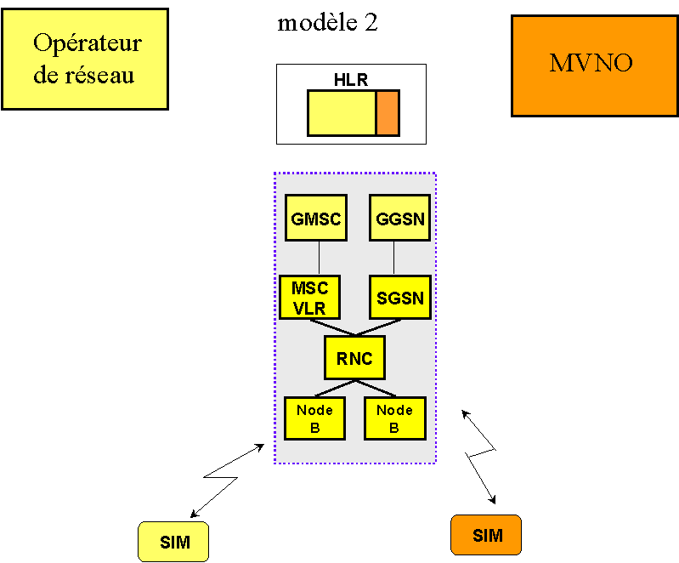
Modèle 2: Model 2
Opérateur de réseau: network operator

- own clientele: here, the third-party player has its own HLR in addition to its own SIM cards, and can therefore manage its own customers (technically: the HLR(s) is/are linked to the host network)

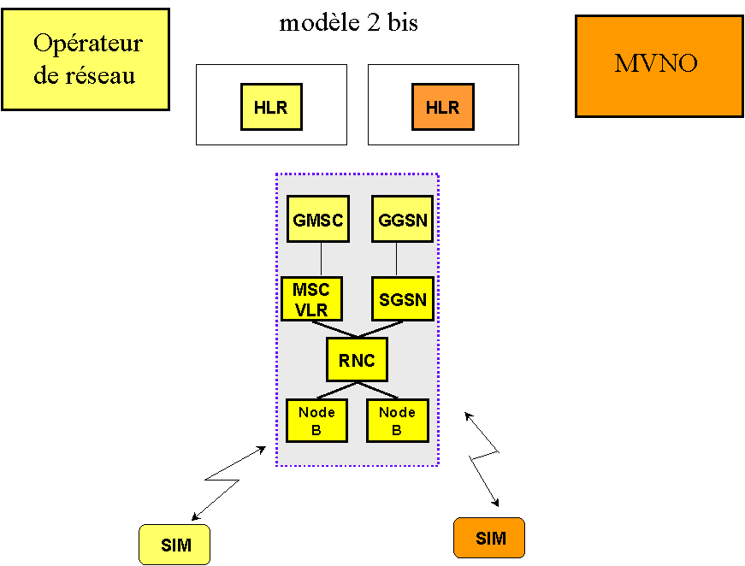
Modèle 2 bis: Model 2b
Opérateur de réseau: network operator

- extended: the third-party player issues its own SIM cards, and has its own HLR. It also has elements of the network core (GMSC; SMSC) connected to the host operator’s network.

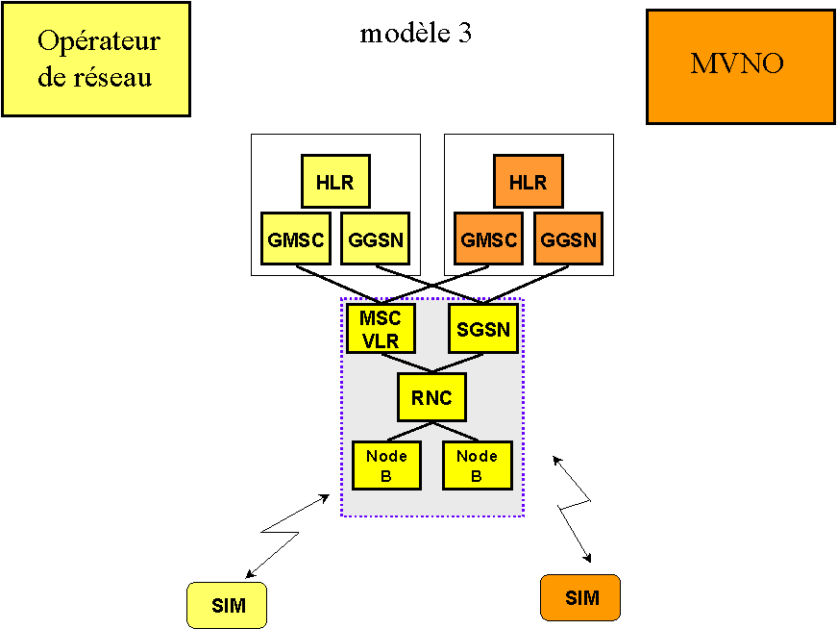
Modèle 3: Model 3
Opérateur de réseau: network operator

___________________________________________________________________

© Autorité de régulation des télécommunications - September 2003
7, Square Max Hymans - 75730 PARIS Cedex 15
Téléphone : +33 1 40 47 70 00 - Télécopie : +33 1 40 47 71 98

